Computational Physics Practical File
Module I – Basic Data Operations

Code 1 – Single Line Plot
import matplotlib.pyplot as plt
x = [1,2,3,4]
y = [1,2,3,4]
plt.plot(x, y, color='green', linestyle='dashed', linewidth =
3,marker='o', markerfacecolor='blue', markersize=12)
plt.xlabel('x – axis')
plt.ylabel('y – axis')
plt.title('My first graph')
plt.show()
Output 1–

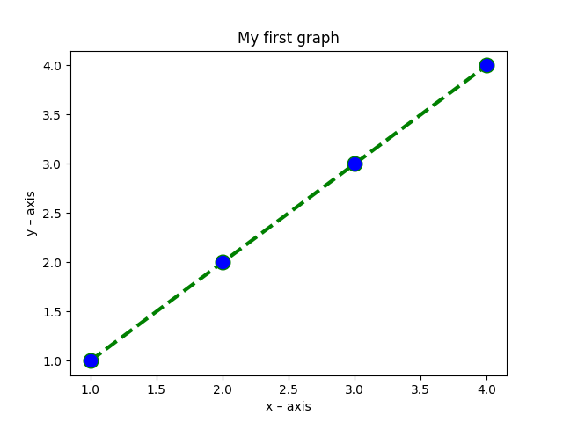

Code 2 – Double Line Plot
import matplotlib.pyplot as plt
x1 = [1,2,3,4]
y1 = [1,2,3,4]
plt.plot(x1, y1, label = "line 1")
x2 = [1,2,3,4]
y2 = [4,3,2,1]
plt.plot(x2,y2, label = "line 2")
plt.xlabel('x – axis')
plt.ylabel('y – axis')
plt.title('Two lines on same graph!')
plt.legend()
plt.show()
Output 2 -
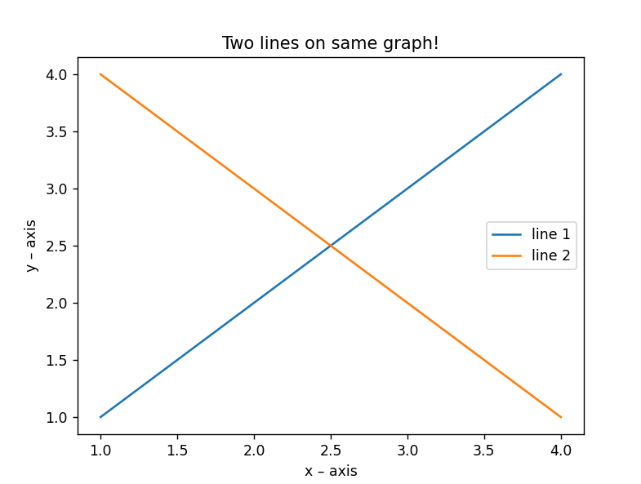

Code 3 – Bar Graph Plot
import matplotlib.pyplot as plt
import numpy as np
y1 = [1,2,3,4]
y2 = [1,2,3,4]
tick_label = ['one', 'two', 'three', 'four']
plt.bar(np.arange(len(y1))-0.2,y1,tick_label = tick_label, width=0.4)
plt.bar(np.arange(len(y2))+0.2,y2,tick_label = tick_label, width=0.4)
plt.title('my bar chart')
plt.legend(labels=['a','b'])
plt.show()
Output 3 –

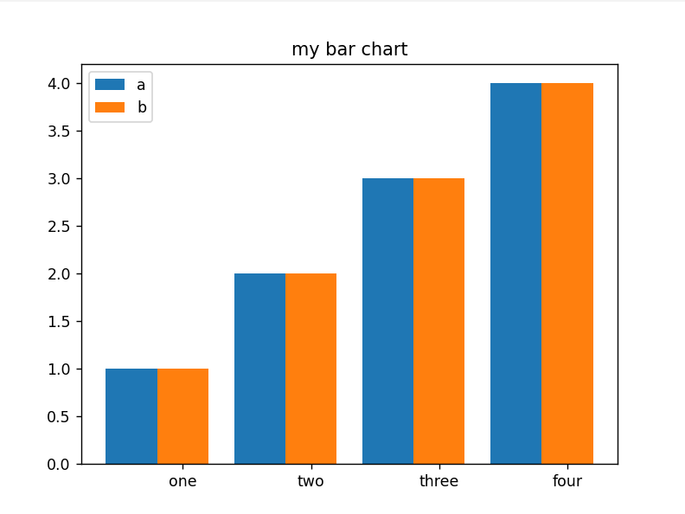

Code 4 – Histogram Plot
import matplotlib.pyplot as plt
ages=[2,5,70,40,30,45,50,45,43,40,44,60,7,13,57,18,90,77,32,21,20,40]
range = (0, 100)
bins = 10
plt.hist(ages, bins, range, edgecolor='black')
plt.xlabel('age')
plt.ylabel('# of people')
plt.title('My histogram')
plt.show()

Output 4 –
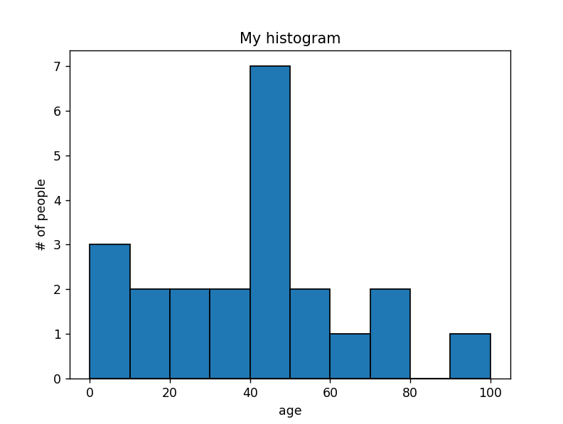

Code 5 – Pie Chart Plot
import matplotlib.pyplot as plt
activities = ['eat', 'sleep', 'work', 'play']
slices = [3, 7, 8, 6]
colors = ['r', 'y', 'g', 'b']
plt.pie(slices, labels = activities, colors=colors,autopct =
'%1.2f%%')
plt.show()

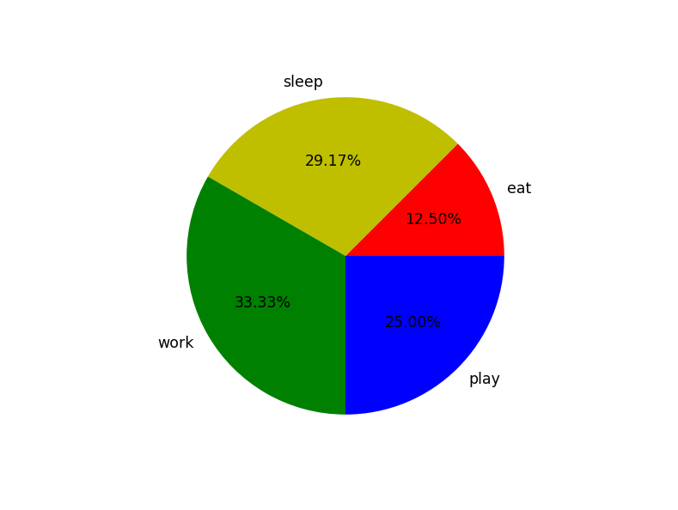
Output 5 –

Code 6 – Scatter Plot
import matplotlib.pyplot as plt
import numpy as np
x = [1,2,3,4,5,6,7,8,9,10]
y = [2,4,5,7,6,8,9,11,12,12]
plt.scatter(x, y)
plt.xlabel('x – axis')
plt.ylabel('y – axis')
plt.title('scatter plot')
plt.xticks(np.arange(min(x), max(x),1.0))
plt.show()

Output 6 –

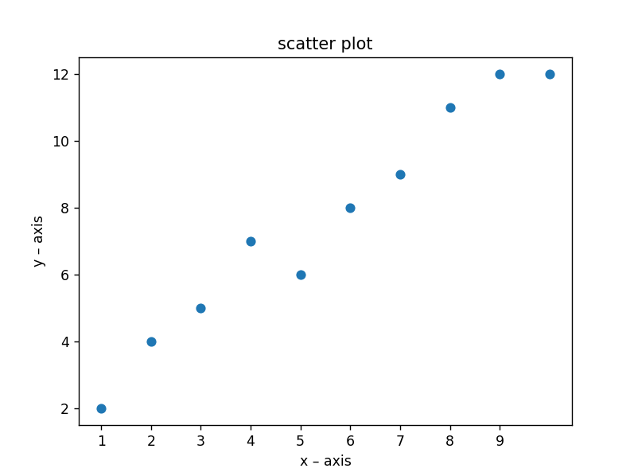

Code 7 – 2-D Meshgrid Plot
import matplotlib.pyplot as plt
import numpy as np
feature_x= np.linspace(0, 3.0,30)
feature_y = np.linspace(0, 3.0, 30)
[X, Y]= np.meshgrid(feature_x, feature_y)
Z=X ** 2+Y ** 2
plt.contourf(X,Y,Z)
plt.show()

Output 7 –
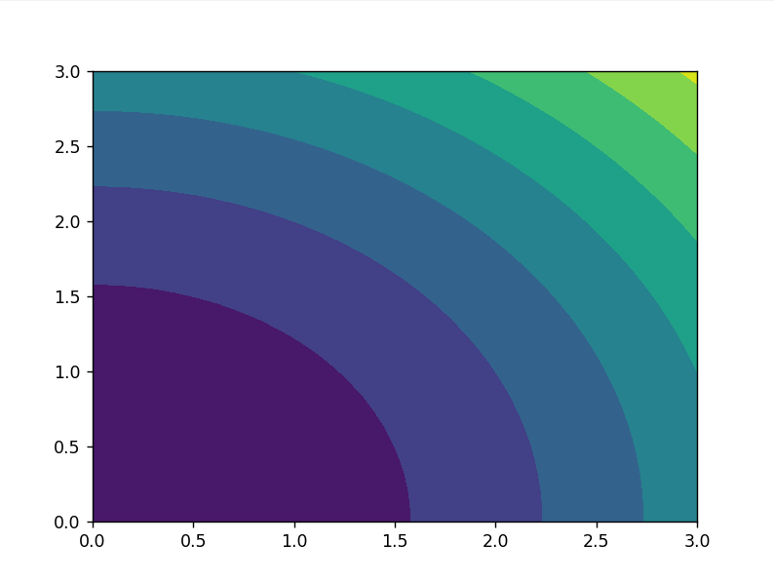

Code 8 – 3-D Plot
import matplotlib.pyplot as plt
import numpy as np
from mpl_toolkits import mplot3d
plt.axes(projection="3d")
x=[1,2,3,4,5]
y=[3,5,2,1,4]
z=[5,2,1,4,3]
plt.plot(x,y,z)
plt.show()

Output 8 –
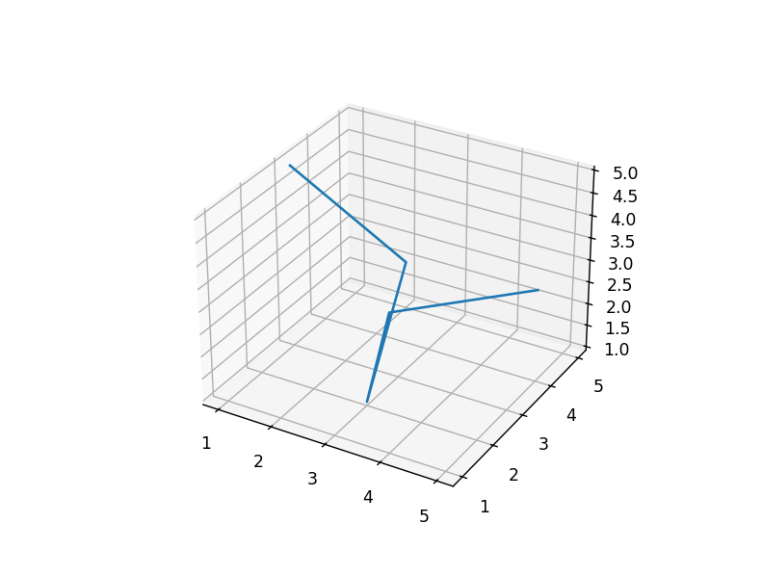

Module II – Mathematical Physics 1
Code 1 – Vector Operations
import numpy as np
list1 = [5, 6, 9]
list2 = [1, 2, 3]
vector1 = np.array(list1)
print("First Vector : " + str(vector1))
vector2 = np.array(list2)
print("Second Vector : " + str(vector2))
addition = vector1 + vector2 #Vector Addition
print("Vector Addition : " + str(addition))
subtraction = vector1 - vector2 #Vector subtraction
print("Vector Substraction : " + str(subtraction))
multiplication = vector1 * vector2 # Vector multiplication
print("Vector Multiplication : " + str(multiplication))
division = vector1 / vector2 # vector division
print("Vector Division : " + str(division))
Output1 –
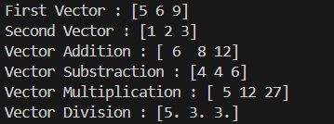

Code 2 – Dot Product of vectors
import numpy
import array
a=[5,6,9]
b=[1,3,4]
dot = 0.0;
for i in range(len(a)):
dot += a[i] * b[i]
print("dot_product = "+ str(dot))

Output 2 –

Code 3 – Dot product of vectors (using internal function)
import numpy as np
list1 = [5, 6, 9]
list2 = [1, 2, 3]
vector1 = np.array(list1)
print("First Vector : " + str(vector1))
vector2 = np.array(list2)
print("Second Vector : " + str(vector2))
dot_product = vector1.dot(vector2)
print("Dot Product : " + str(dot_product))

Output3 –
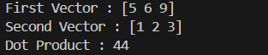

Code 4 (a)– Cross Product of Vectors
vect_A = [3, -5, 4]
vect_B = [2, 6, 5]
cross_P = [ ]
cross_P.append(vect_A[1] * vect_B[2] - vect_A[2] *vect_B[1])
cross_P.append(vect_A[2] * vect_B[0] - vect_A[0] * vect_B[2])
cross_P.append(vect_A[0] * vect_B[1] - vect_A[1] * vect_B[0])
print("Cross product:", end =" ")
for i in range(0, 3):
print(cross_P[i], end =" ")

Output 4 (a)–

Code 4(b) – Cross Product of Vectors (using Internal function)
import numpy as np
A =[2, 7, 4]
B =[3, 9, 8]
vector1=np.array(A)
vector2=np.array(B)
cross_product=np.cross(vector1, vector2)
print("Cross product :" +str(cross_product))

Output 4(b)–

Code 5 – Addition of two matrices
import numpy as np
M1 = np.array([[3, 6, 9], [5, -10, 15], [-7, 14, 21]])
M2 = np.array([[9, -18, 27], [11, 22, 33], [13, -26, 39]])
M3 = M1 + M2
print(M3)

Output 5 –

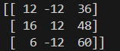

Code 6 – Subtraction of two matrices
import numpy as np
M1 = np.array([[3, 6, 9], [5, -10, 15], [-7, 14, 21]])
M2 = np.array([[9, -18, 27], [11, 22, 33], [13, -26, 39]])
M3 = M1 - M2
print(M3)

Output 6 –

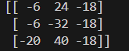

Code 7 – Dot product of two matrices
import numpy as np
M1 = np.array([[3,6,9],[5,-10,15],[-7,14,21]])
M2 = np.array([[9,-18,27],[11,22,33],[13,-26,39]])
M3 = M1.dot(M2)
print(M3)

import numpy as np
mat1 = ([1, 6, 5],[3 ,4, 8],[2, 12, 3])
Mat2 = ([3, 4, 6],[5, 6, 7],[6, 56, 7])
res = np.dot(mat1,Mat2)
print(res)

Output 7 –

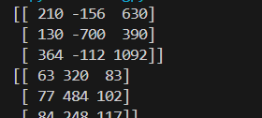

Code 8 – Transpose of a matrix
import numpy as np
M1 = np.array([[3,6,9],[5,-10,15],[4,8,12]])
M2 = M1.transpose()
print(M1)
print(M2)

Output 8 –

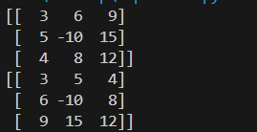

Code 9 – Inverse of a matrix
import numpy as np
A = np.array([[6, 1, 1], [4, -2, 5], [2, 8, 7]])
B = np.linalg.inv(A)
print (B)

Output 9 –
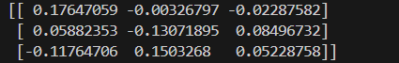

Module III – Mathematical Physics II

Code 1 – Graph for 4 Equations
import matplotlib.pyplot as plt
import numpy as np
fig = plt.figure()
ax = fig.add_subplot(1, 1, 1)
x = np.linspace(-5,5,100)
ax.spines['left'].set_position('center')
ax.spines['bottom'].set_position('center')
ax.spines['right'].set_color('none')
ax.spines['top'].set_color('none')
ax.xaxis.set_ticks_position('bottom')
ax.yaxis.set_ticks_position('left')
plt.plot(x, 2*x+1, 'r', label='y=2x+1')
plt.plot(x, 2*x-1,'g', label='y=2x-1')
plt.plot(x, 2*x+3,'b', label='y=2x+3')
plt.plot(x, 2*x-3,'k', label='y=2x-3')
plt.legend(loc='upper left')
plt.show()

Output 1-

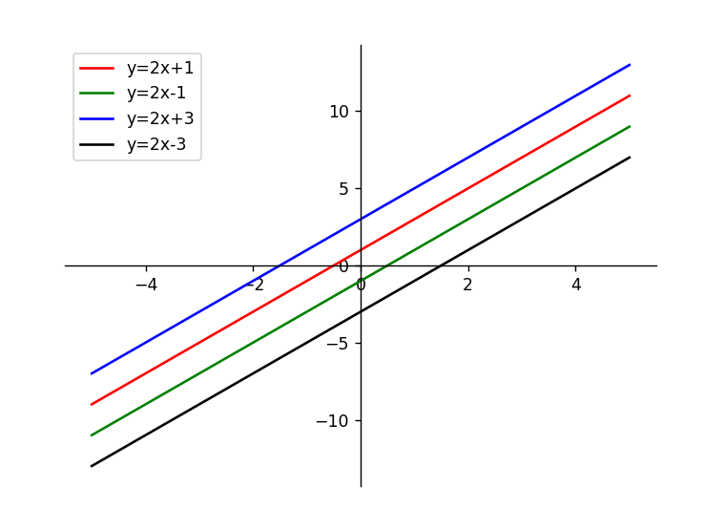

Code 2 – Graph of Curve
import matplotlib.pyplot as plt
import numpy as np
x = np.linspace(-2, 2, 100)
y = x ** 2
fig = plt.figure(figsize = (10, 5))
plt.plot(x, y)
plt.show()

Output 2 –
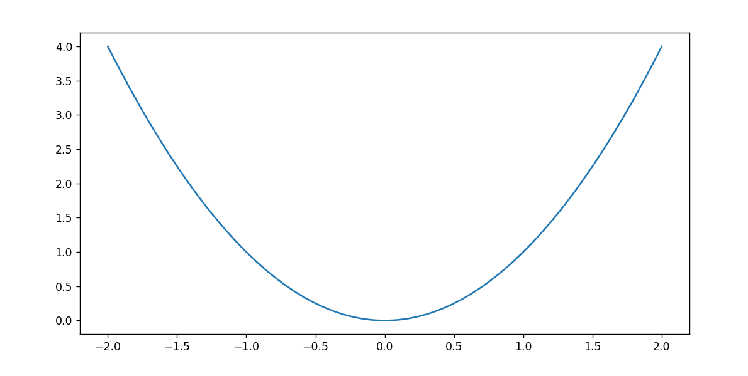

Code 3 – Graph of cos(x) function
import matplotlib.pyplot as plt
import numpy as np
x = np.linspace(-6, 6, 50)
y = np.cos(x)
plt.plot(x, y, 'b', label ='cos(x)')
plt.xlabel('x-axis')
plt.ylabel('y-axis')
plt.show()

Output 3 –
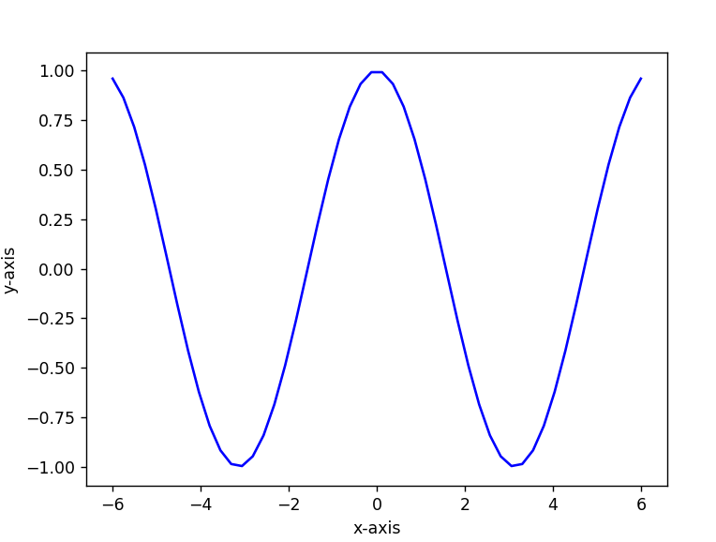

Code 4 – Graph for exponential function e(x)
import matplotlib.pyplot as plt
import numpy as np
x = np.linspace(0, 1, 1000)
y = np.exp(x)
plt.plot(x, y, 'b', label ='exp(x)')
plt.xlabel('x-axis')
plt.ylabel('y-axis')
plt.show()

Output 4 –
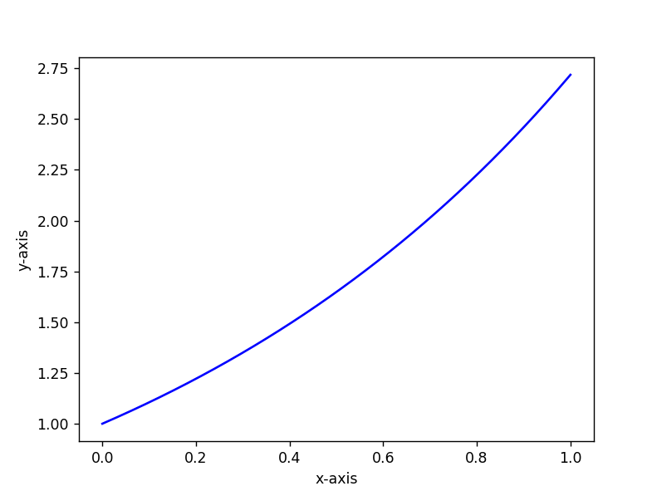

Code 5 – Graph for logarithmic function(ln(x))
import matplotlib.pyplot as plt
import numpy as np
x = np.linspace(1, 100, 1000)
y = np.log(x)
plt.plot(x, y, 'b', label ='ln(x)')
plt.xlabel('x-axis')
plt.ylabel('y-axis')
plt.show()

Output 5 –

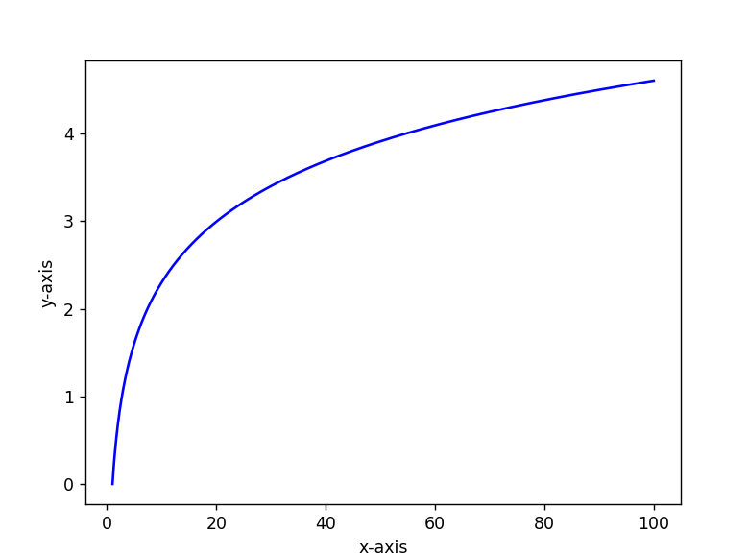

Code 6 – Using statictics module to compute median of a given dataset.

import numpy as np
import statistics
data1 = [1, 3, 4, 5, 7, 9, 2]
print("Median of data-set is : ", statistics.median(data1))

Output 6 –

Code 7 – Using statictics module to compute mode of a given dataset.

import statistics
set1 =[1, 2, 3, 3, 4, 4, 4, 5, 5, 6]
print("Mode of given data set is :", (statistics.mode(set1)))

Output 7 –

Code 8 – Using statictics module to compute std. deviation of a given dataset.

import statistics
sample = [1, 2, 3, 4, 5]
print("Standard Deviation of sample is:(statistics.stdev(sample))

Output 8 –

Code 9 – Using Rand function in numpy.random module.
from numpy.random import rand
for i in range(10):
print(rand())

Output 9 –

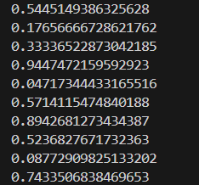

Code 10 – Using randint function in numpy.random module.

from numpy.random import randint
for i in range(10):
print(randint(0,10))

Output 10 –

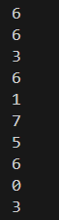

Code 11 – Graph for list of random values
from numpy.random import rand
import matplotlib.pyplot as plt
l=[]
for i in range(10):
l.append(rand())
print(l)
plt.plot(l)
plt.show()

Output 11 –
